**BATCH-2401F**

**E-PROJECT**

**E-PROJECT**

## Venus Handicrafts

##### Group Members Submitted To

1. ABDUL REHMAN [eprojects@aptechfze.ae](mailto:eprojects@aptechfze.ae) Student1548531
2. **MUDASSIR RIASAT PROJECT INSTRUCTOR**

Student1549658 AHSAN RAZA

3- ZAKARIA

**Student1548774 CURRICULUM CODE**

4- MUSTAFA ALAM OV-ACCP Prime-7062-ACE

**Student1553083**

**1**

OXFORDS SOFA

**BATCH-2401F**

**2**

**E-PROJECT**

# TABLE OF CONTENT

ACKNOWLEGDMENT 3

PROJECT CERTIFICATION 4

INTRODUCTION 5

REQUIRMENT SPECIFICATION 5

1. HARDWARE REQUIRMENT. 6
2. SOFTWARE REQUIRMEN. 6

PROJECT DURATION 7

TASK SHEET. 8

SNAPSHOT 9

Venus Handicrafts

**BATCH-2401F**

**3**

**E-PROJECT**

# ACKNOWLEDGEMENT

###### We are thankful to Almighty, **ALLAH** that by his grace we have been successful. We are presenting our E-project in your hands. We have tried our best to take all relevant important topics in consideration so that this project may become comprehensive and we would like to thank our very supportive Faculty Member Sir, Irfan Ahmed.

This is our **First Semester E**-project. We have tried our best and struggled for a better results to come. This project has been developed in **Visual Studio Code.** We choose to make webpage for **OXFORD SOFAS** as a project. We find easy to do coding in **Visual Studio Code.**

###### We earnestly hope that this project will provide all the necessarily information required for the user to fulfill their inspiration. However suggestions for improvement of the project will be thankfully received and acknowledge.

Venus Handicrafts

**BATCH-2401F**

**E-PROJECT**



# E-PROJECT

**CETIFICATION**

#### This Is to Certify That,

**ABDUL REHMAN, MUSTAFA ALAM, ZAKARIA and MUDASIR RIASAT**

#### Has Successfully Designed and Developed eProject

**“OXFORD SOFAS”**

#### Date of Issue: 17-JUNE-2024

**BATCH-2401F**

**E-PROJECT**

**4**

**OXFORD SOFAS**

# INTRODUCTION

The thirst for learning, upgrading technical skills and applying the concepts in real life environment at a fast pace is what the industry demands from IT professionals today. However busy work schedules, far- flung locations, unavailability of convenient time-slots pose as major barriers when it comes to applying the concepts into realism. And hence the need to look out for alternative means of implementation in the form of laddered approach.

The above truly pose as constraints especially for our students too! With their busy schedules, it is indeed difficult for our students to keep up with the genuine and constant need for integrated application which can be seen live especially so in the field of IT education where technology can change on the spur of a moment. *Well, technology does come to our rescue at such times!!*

Keeping the above in mind and in tune with our constant endeavour to use Technology in our training model, we at Aptech have thought of revolutionizing the way our students learn and implement the concepts using tools themselves by providing a *live and synchronous eProject learning environment!*

**So what is this eProject?**

eProject is a step-by-step learning environment that closely simulates the classroom and Lab based learning environment into actual implementation. It is a project implementation at your fingertips!! An electronic, live juncture on the machine that allows you to

* Practice step by step i.e. laddered approach.
* Build a larger more robust application.
* Usage of certain utilities in applications designed by user.
* Single program to unified code leading to a complete application.
* Learn implementation of concepts in a phased manner.
* Enhance skills and add value.
* Work on real life projects.
* Give a real life scenario and help to create applications more complicated and useful.
* Mentoring through email support.

**5**

OXFORD SOFAS

**BATCH-2401F**

**6**

**E-PROJECT**

# REQUIRMENT SPECIFICATION

##### Hardware

###### A minimum computer system that will help you access all the tools in the courses is a Pentium 166 or better

* 64 Megabytes of RAM or better

##### Software

###### Notepad/HTML editor

* Dreamweaver

###### IE 5.0/ Netscape 6.0

OXFORD SOFAS

**BATCH-2401F**

**7**

**E-PROJECT**

# PROJECT DURATION

* **ANALYSIS** 5 HOURS
* **DESIGN** 7 HOURS
* **DEVELOPMENT 4** HOURS
* **TESTING** 2 HOURS
* **DOCUMENTATION** 3 HOURS



**HOURS**

8

7

6

5

4

Hours

3

2

1

0

ANALYSIS

DESIGN

DEVELOPMENT

TESTING

DOCUMENT

OXFORD SOFAS

**BATCH-2401F**

**8**

**E-PROJECT**

# TASK SHEET

|  |  |  |  |  |  |
| --- | --- | --- | --- | --- | --- |
| ***No*** | ***Task*** | ***Actual Start Date*** | ***Actual Days*** | ***Team Mate Name*** | ***Status*** |
| ***1.*** | ***Analysis*** | ***17-JUNE-2024*** | ***3*** | ***ABDUL REHMAN, MUSTAFA ALAM, MUDASAIR RIASAT, ZAKARIA*** | ✓ |
| ***2.*** | ***Design*** | ***20-JUNE-2024*** | ***5*** | ***ABDUL REHMAN, MUSTAFA ALAM, MUDASAIR RIASAT, ZAKARIA*** | ✓ |
| ***3.*** | ***Development*** | ***25-JUNE-2024*** | ***4*** | ***ABDUL REHMAN, MUSTAFA ALAM, MUDASAIR RIASAT, ZAKARIA*** | ✓ |
| ***4.*** | ***Testing*** | ***29-JUNE-2024*** | ***2*** | ***ABDUL REHMAN, MUSTAFA ALAM, MUDASAIR RIASAT, ZAKARIA*** | ✓ |
| ***5.*** | ***Documentation*** | ***1-JULY-2024*** | ***2*** | ***ABDUL REHMAN, MUSTAFA ALAM, MUDASAIR RIASAT, ZAKARIA*** | ✓ |
| ***6.*** | ***Finalization*** | ***3-JULY-2024*** | ***1*** | ***ABDUL REHMAN, MUSTAFA ALAM, MUDASAIR RIASAT, ZAKARIA*** | ✓ |

**Home Page**

**BATCH-2401F**

# SNAP SHOTS

**E-PROJECT**

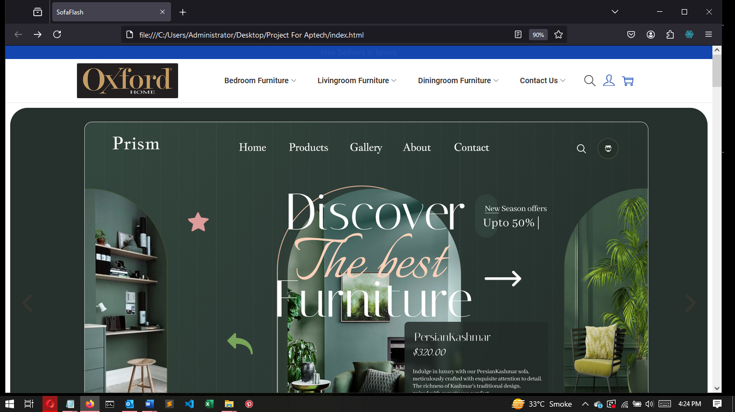

OXFORD

**9**

**BATCH-2401F**

**10**

**E-PROJECT**

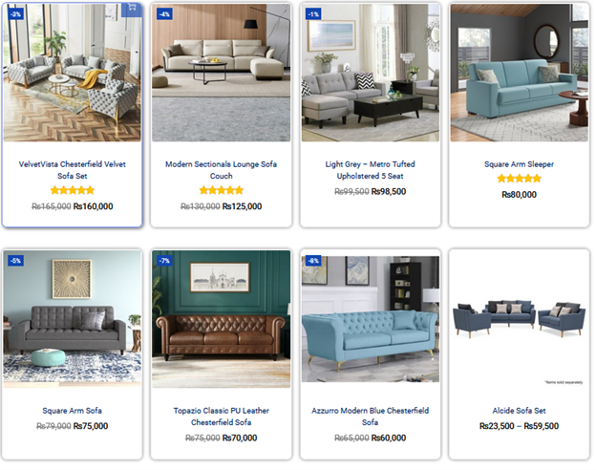

OXFORD SOFAS

***SOFAS***

**BATCH-CF2110B**

**11**

**E-PROJECT**

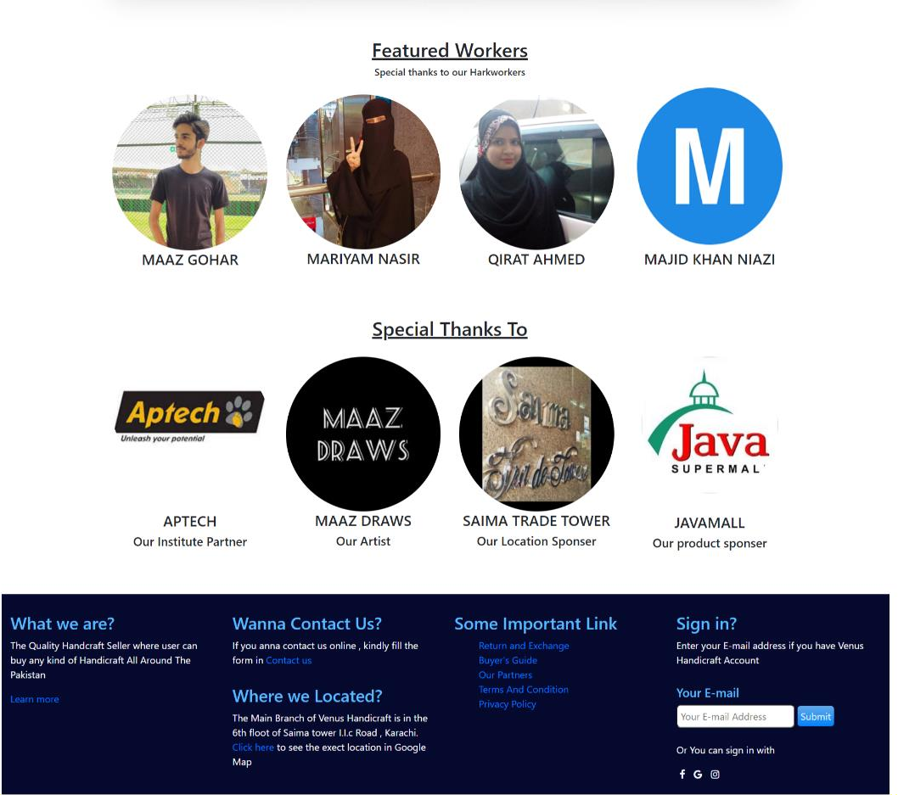

OXFORD SOFAS

**BATCH-2401F**

**E-PROJECT**

**Products**

**SOFAS TYPES**

OXFORD SOFAS

**12**

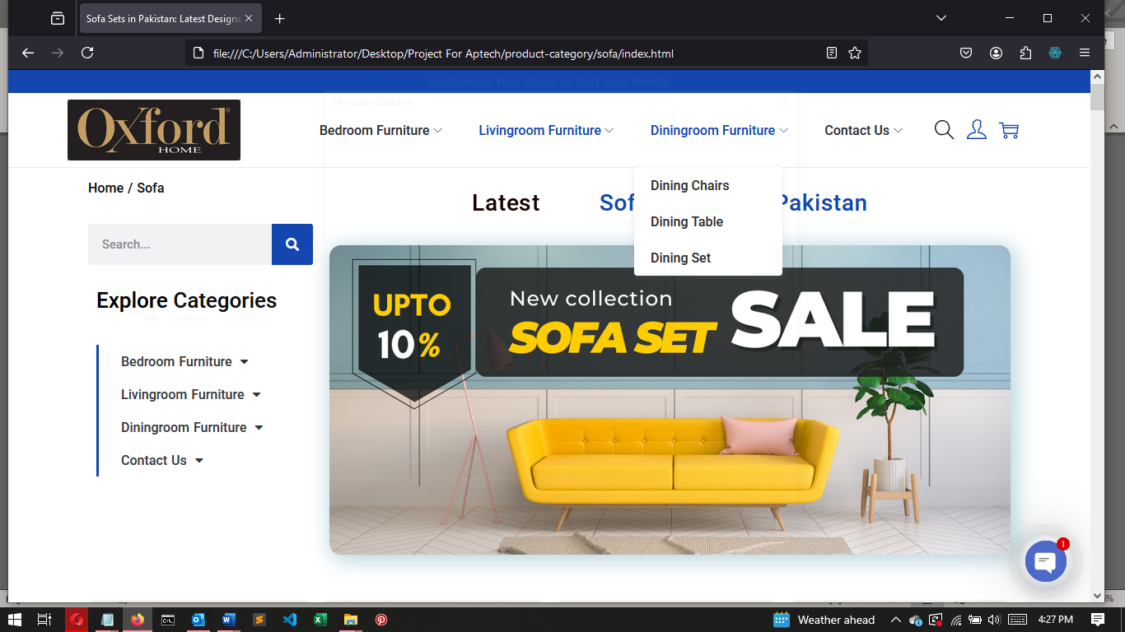

**BATCH-2401F**

**E-PROJECT**

#### SOFA CHAIRS

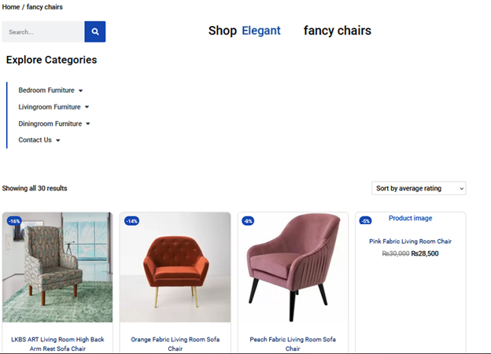

OXFORD SOFAS

**BATCH-2401F**

**19**

**E-PROJECT**

#### Home Decor

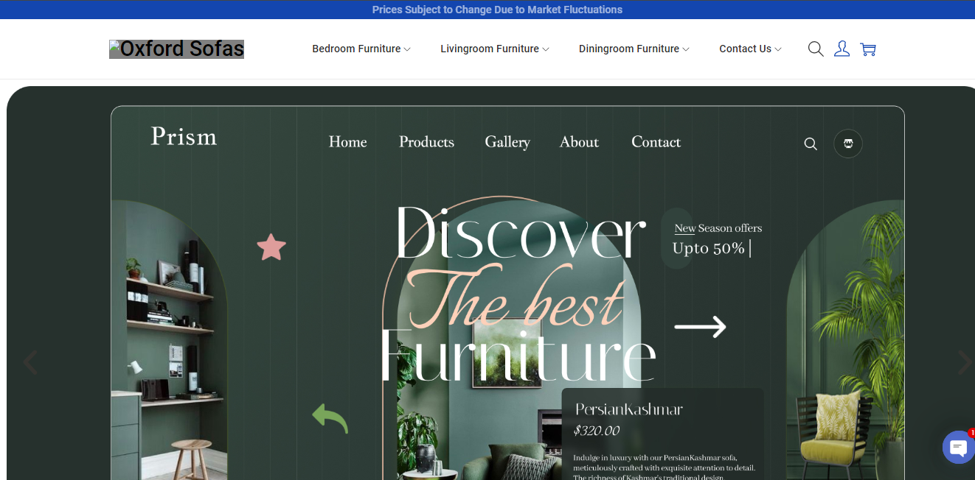

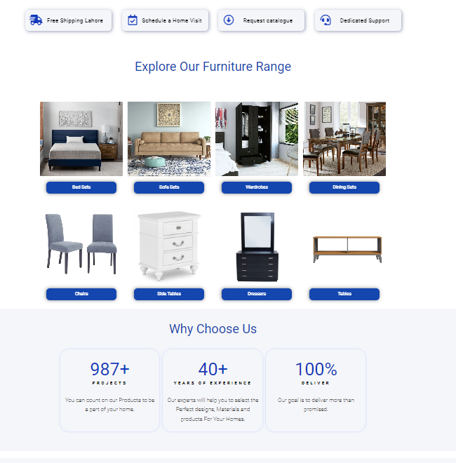

OXFORD SOFAS

**BATCH-2401F**

**20**

**E-PROJECT**

#### SOFA

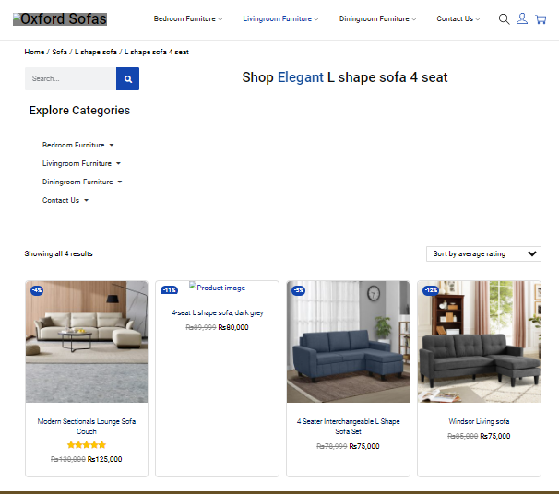

OXFORD SOFAS

**BATCH-2401F**

**21**

**22**

**E-PROJECT**

#### Contact Us Page

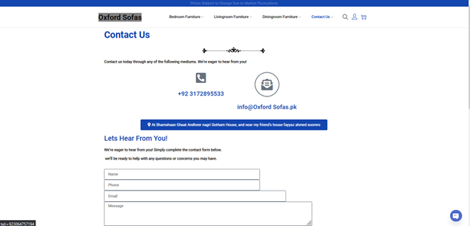

OXFORD SOFAS

**BATCH-2401F**

**23**

**E-PROJECT**

**VENUS HANDICRAFTS**

### USER GUIDE

OXFORD SOFAS

**BATCH-2401F**



**E-PROJECT**

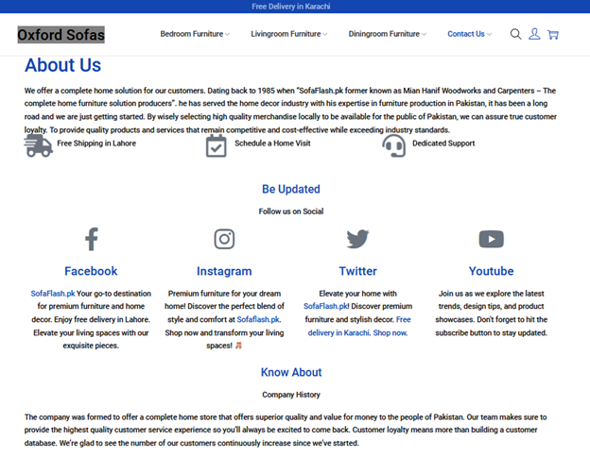

This is our ABOUT-US

**By clicking these images, you will reach the about page of the webpage.**

**25**

OXFORD SOFAS

**BATCH-2401F**

**E-PROJECT**

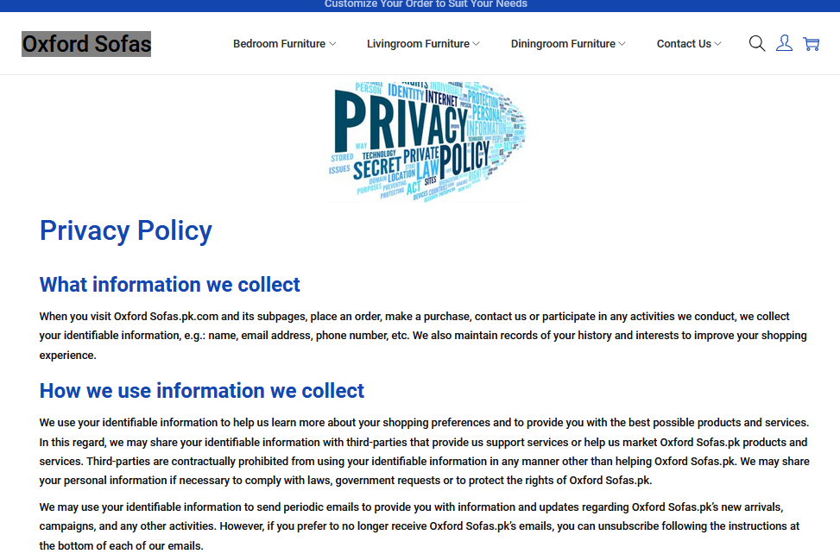

This is our Privacy Policy page

OXFORD SOFAS

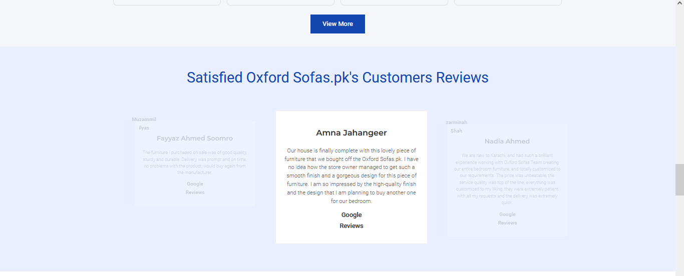

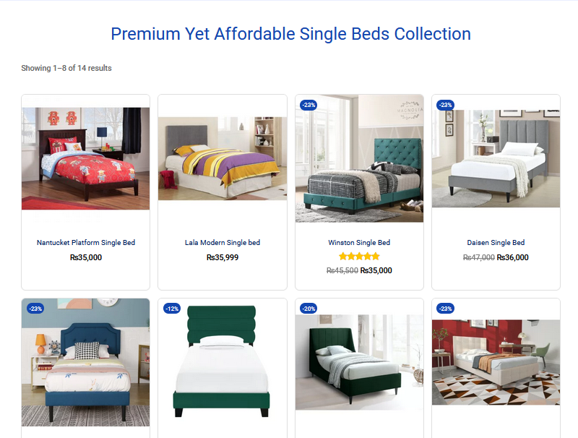

**Our Partners**

**These are our partners who make the important contribution in building of Venus Handicraft.**

**27**

**This is Footer**

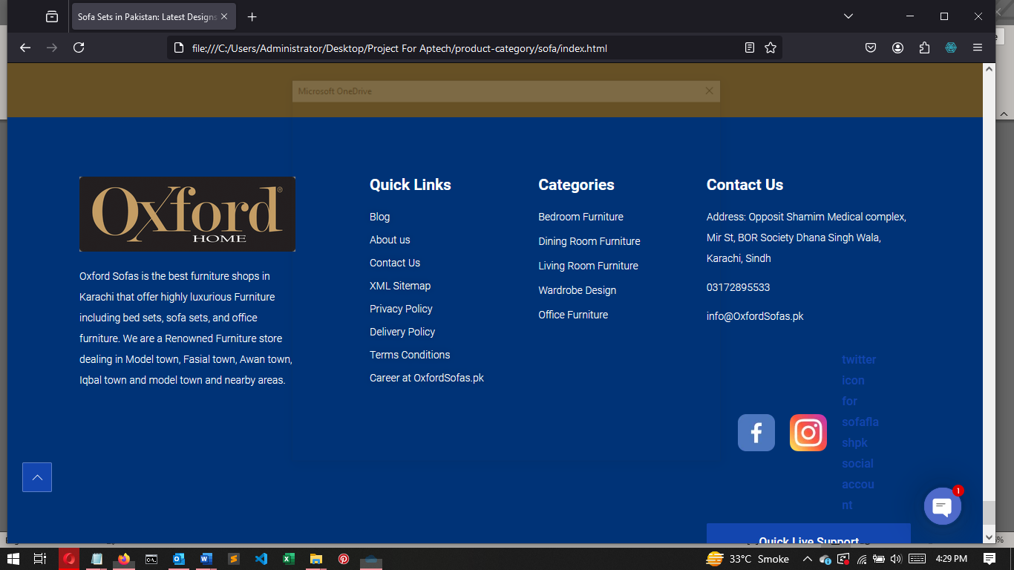

**This is the footer of our website, where you will find some important pages like Terms and condition, Privacy Policy, Location ETC.**

OXFARD SOFAS

**BATCH-2401F**

**29**

**E-PROJECT**



## VENUS HANDICRAFTS

### DEVELOPER GUIDE

OXFARD SOFAS

**BATCH-2401F**

**31**

**E-PROJECT**

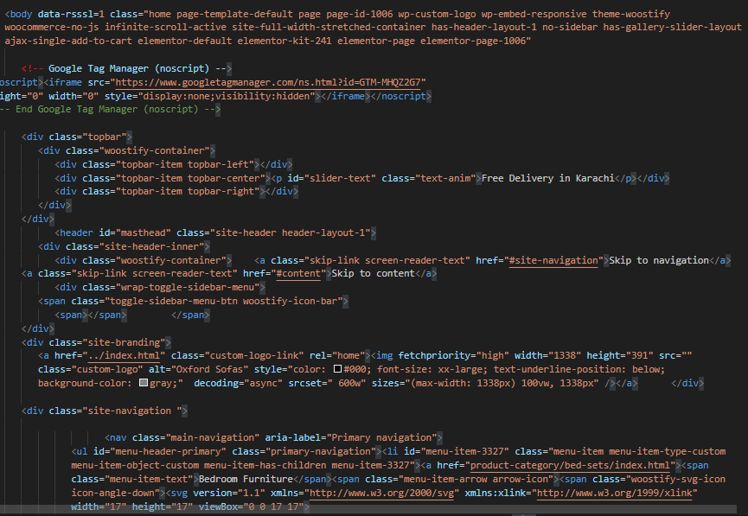

OXFARD SOFAS

**BATCH-2401F**

**E-PROJECT**

**This Is Product Page**

Product description and customization (**on the right**) Product images (**on the left**)

In this section, we’ll have more elements (**buttons, radios, links**) Ok, let’s wrap everything in a `.container` class.

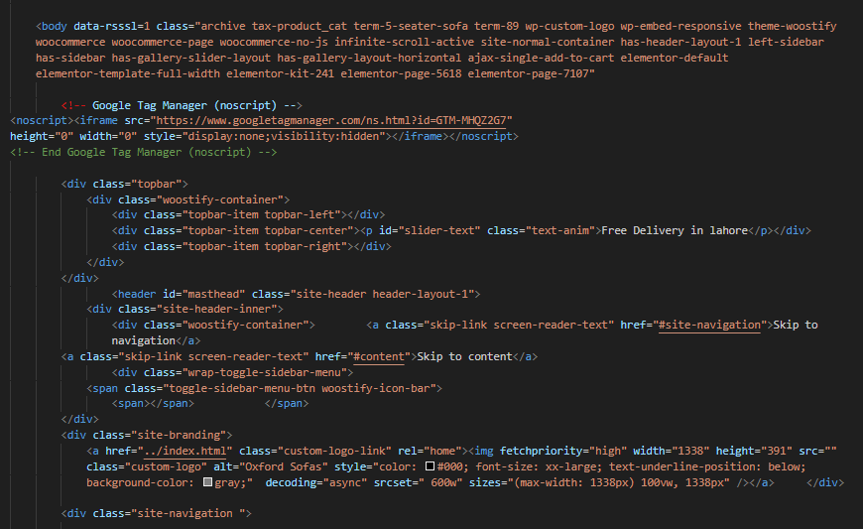

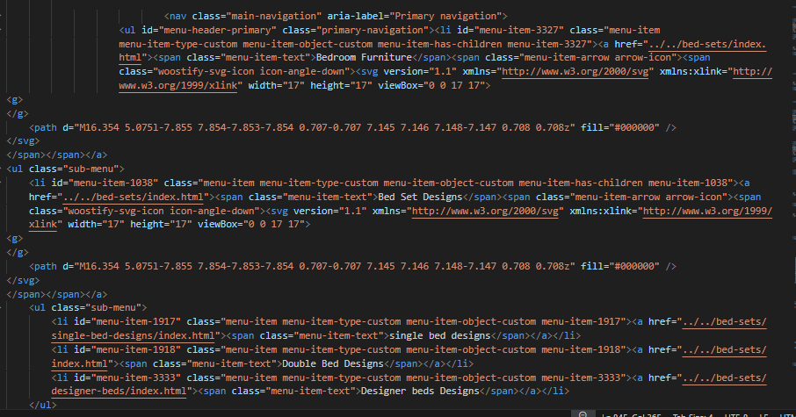

OXFARD SOFAS

**32**

**BATCH-2401F**

**33**

**E-PROJECT**

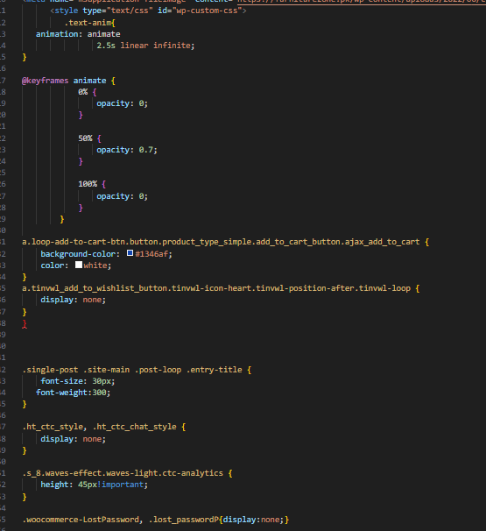 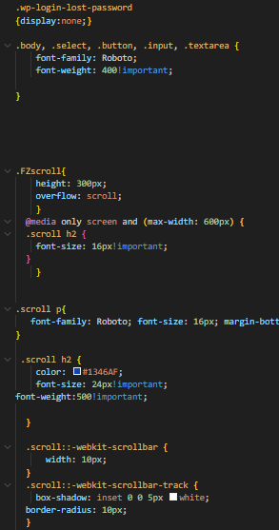 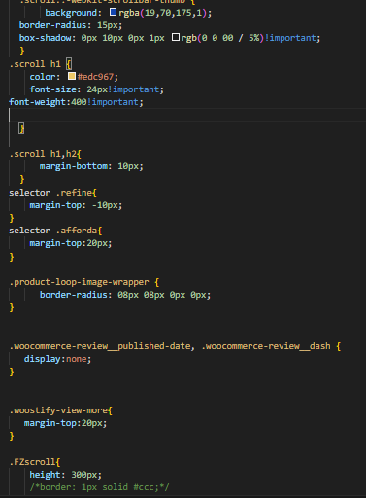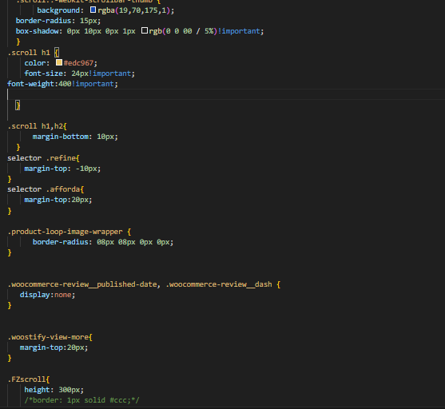

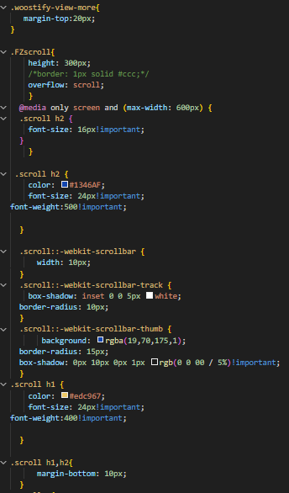 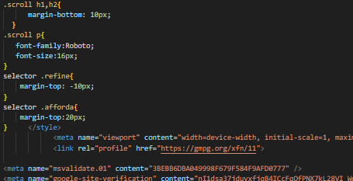

#### This Is Home Page CSS

OXFARD SOFAS

**BATCH-2401F**

**34**

**E-PROJECT**

#### The Developers is little incomplete because we have already added comments in our website code so you will be able to understand our site structure easily and you can also edit and change any code with your choice.

**Thanks**

#### Best Regards,

OXFORD SOFAS